**Meeting 1: 16.01.2024 14: 00 – 17: 00**

The first meeting took place at Maarintie 8, room 2530, with Dr. Saba, Jingtao Zhong, and Xingji Chen in attendance. During the meeting, Dr. Saba introduced the general content and direction of the project, detailing what we were preparing to measure and how the measurements would be carried out. As depicted in the following pictures, Dr. Saba created a map of the measurement area and a log sheet for recording data.

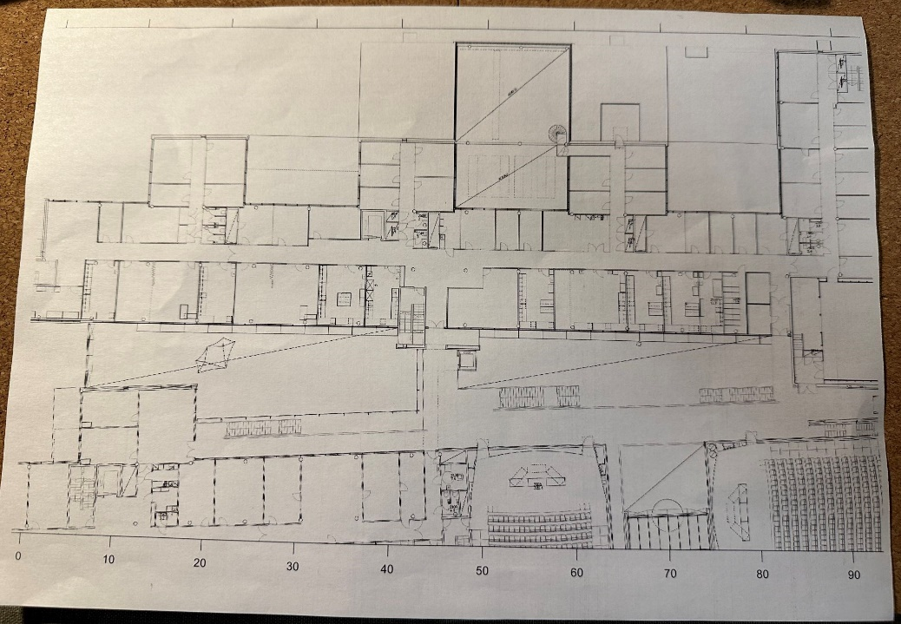

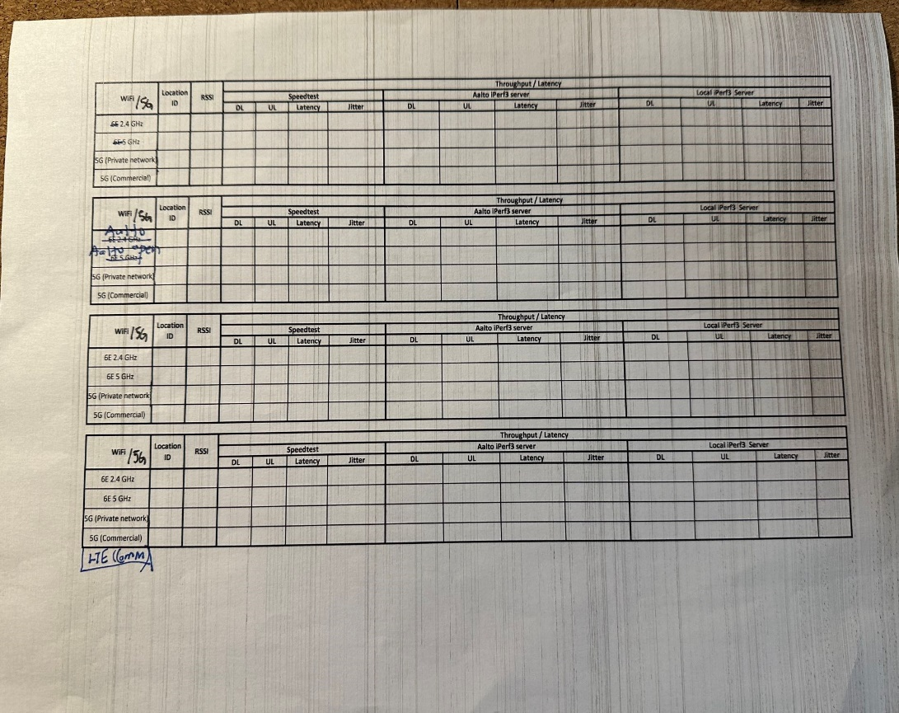

In this project, we are set to measure Wi-Fi signals at frequencies of 2.4GHz and 5GHz, as well as commercial LTE and 5G signals. For each type of signal, it is necessary to record the measurement location and the RSSI (Received Signal Strength Indicator) at that location. Measurements of download and upload throughput, latency, and jitter will be conducted using Speedtest, the Aalto iPerf 3 server, and a local iPerf 3 server.

**Meeting 2: 25.01.2024 14: 00 – 17: 00**

The second meeting was held in the coffee room at Maarintie 8, with Dr. Saba, Jingtao Zhong, and Xingji Chen in attendance. During the meeting, Dr. Saba provided us with background information about the project. User Equipment (UE) employs the iPerf3 tool for network performance testing. iPerf3 is a network measurement utility used to determine the maximum bandwidth capacity. The UE utilizes the ping command to assess network latency.

When devices are connected to Wi-Fi or a Mobile Network, we use iPerf3, ping commands, and the Speedtest tool to measure various network parameters such as throughput, latency, and jitter in different network environments. With regards to different protocols like TCP and UDP, we aim to compare the performance of these protocols through our measurement results. We will conduct our network measurements using laptops. The project topic has been identified as "Wi-Fi and Mobile Network Performance Measurement for IIoT". Dr. Saba introduced us to the use of different tools and some methods for data processing.

The main content of the meeting is shown in the figure below:

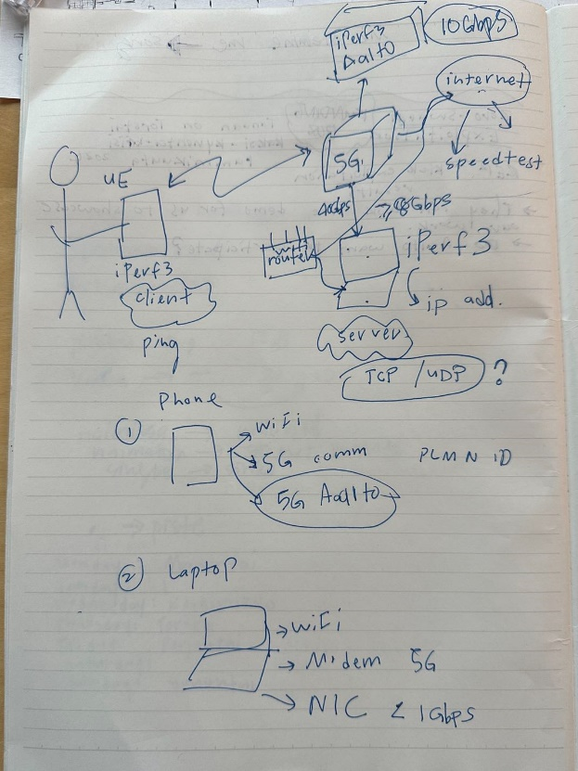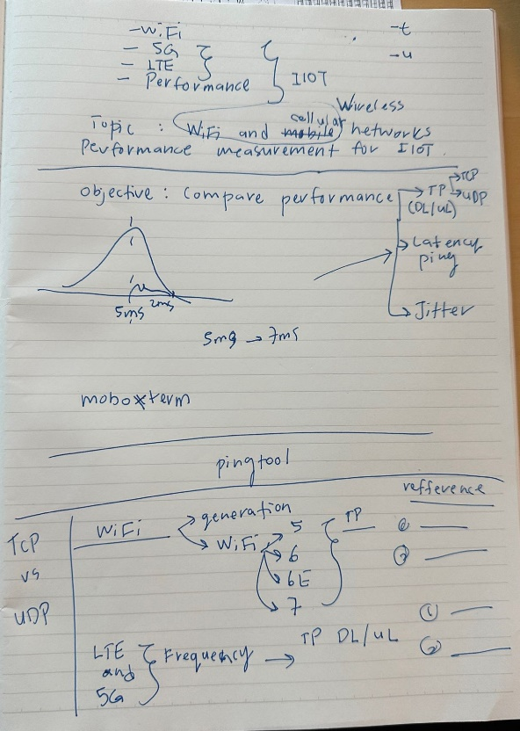

After the meeting concluded, our task was to familiarize ourselves with the relevant software applications and knowledge. We are to consult resources to complete the following tasks:

1. TCP vs UDP comparison
2. WiFi generations (WiFi5, WiFi6, WiFI6e, and WiFi7) - examining bandwidth and throughput capacities
3. LTE and 5G technologies (frequencies used) - identifying normal throughput for uplink (UL) and downlink (DL)
4. Jitter measurement in networks.

**Meeting 3: 01.02.2024 14: 00 – 17: 00**

We practice the basic operation of measurement (speedtest, ping, iperf), and we measured the network performance of the meeting room (second floor of TUAS building). Then, we learned how to use Netspot. At last, we try to use the modem to receive signal, but we failed.

**Meeting 4: 07.02.2024 14: 00 – 17: 00**

We learned how to use Keysight’s Nemo software to measure the performance of mobile network and Wi-Fi. We connected the laptop with the modem and we measured the network performance of 4G. Then, we gave a preliminary plan on how to measure: Measure Mobile and Wi-Fi at one point sequentially. After getting all the information about one point, we move to the next point.

**Meeting 5: 15.02.2024 14: 00 – 17: 00**

We had a meeting at Maarintie 8, room 2519, with Dr. Saba, Jingtao Zhong, and Xingji Chen in attendance. During the meeting, Dr. Saba introduced us to the usage of Overleaf. Overleaf is an online LaTeX editor that allows users to create, edit, and share LaTeX documents online. Dr. Saba shared with us the link to the paper we were going to complete, enabling us to work on the same document simultaneously. Then, Dr. Saba introduced us to her frequently used tool, EndNote. EndNote is a reference management software that can be used to organize, manage, and format their citations and bibliographies. Dr. Saba taught us how to use it and how to manage references. She created a literature database for us to use in our special project, saving detailed information about many references.

We asked some questions about MATLAB code. In the program, we needed to convert the actual coordinates of measurement locations into pixel points annotated on the map, and we were unclear about the correspondence between the two. Dr. Saba explained these issues to us and told us how to determine the positions of the measurement points on the map. She also shared another program with us. In this program, 45 measurement points are marked within a 90-meter area, meaning the distance between each point is 2 meters. This helps us to continue our measurement work.

**Meeting 6: 16.02.2024 14: 00 – 16: 00**

We had a meeting at Maarintie 8, room 2530, with Dr. Saba, Jingtao Zhong, and Xingji Chen in attendance. Dr. Saba introduced us to today's task. She presented the 3D Scanner App, an application that can capture the geometry of objects or environments using the camera of a smartphone or tablet by taking multiple photos from different angles to create 3D models. We planned to create a 3D model of the corridor area. Dr. Saba printed some pixel block images, which, by incorporating them into different models, can sequentially link various 3D models together. We distributed and affixed these images on the walls of the corridor area.

**Meeting 7: 29.02.2024 14: 00 – 20: 00**

We had a meeting at Maarintie 8, room 2530, with Dr. Saba, Jingtao Zhong, and Xingji Chen in attendance.Firstly, Dr. Saba introduced us to the Aruba AP22, which supports Wi-Fi 6 (802.11ax). Not only does it offer higher data rates, but it also provides greater capacity and improved power efficiency, especially in crowded network environments. We successfully set up the Aruba AP22 and managed to connect a laptop using the Wi-Fi 6 module. Following that, we utilized various tools, including ping, iperf, and speedtest, to evaluate the performance of the Wi-Fi 6 network. The test results showed that Wi-Fi 6 could deliver higher transmission rates and throughput, with lower latency compared to Aalto open. Subsequently, we placed the Aruba AP22 in the hallway on the second floor of Maarintie 8, measured the strength of the Wi-Fi 6 signal at different locations, and marked them on a map. The measurements indicated that the Wi-Fi 6 signal could almost cover the entire hallway, with a reach of 60 to 70 meters.

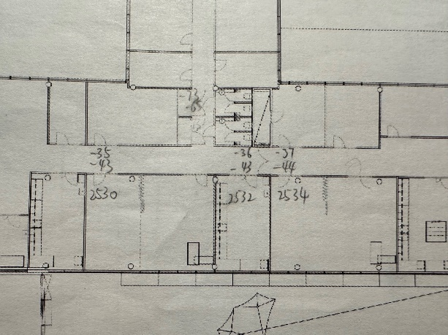 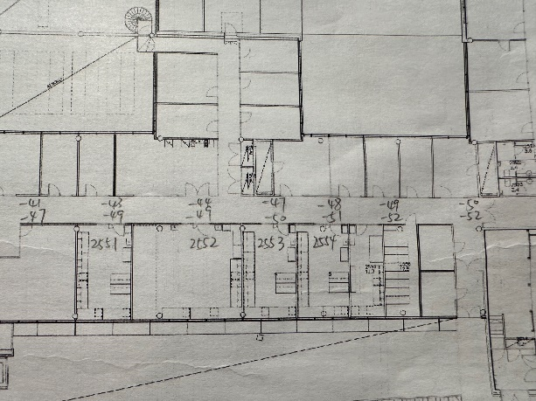

In the subsequent discussion, Dr. Saba suggested that we set up one laptop as an iperf server and another laptop as an iperf client, and then conduct network performance testing using iperf. We encountered issues with this task, finding that while the ping command worked normally, the iperf command always showed timeouts or failed to connect. This is a problem we need to resolve.